Week 1--- System Design
Exercise 1: Implementing the Singleton Pattern
Scenario:
You need to ensure that a logging utility class in your application has only one instance throughout the application lifecycle to ensure consistent logging.
Steps:
- Create a New Java Project:
  - Create a new Java project named SingletonPatternExample.
- Define a Singleton Class:
  - Create a class named Logger that has a private static instance of itself.
  - Ensure the constructor of Logger is private.
  - Provide a public static method to get the instance of the Logger class.
- Implement the Singleton Pattern:
  - Write code to ensure that the Logger class follows the Singleton design pattern.
- Test the Singleton Implementation:
  - Create a test class to verify that only one instance of Logger is created and used across the application.
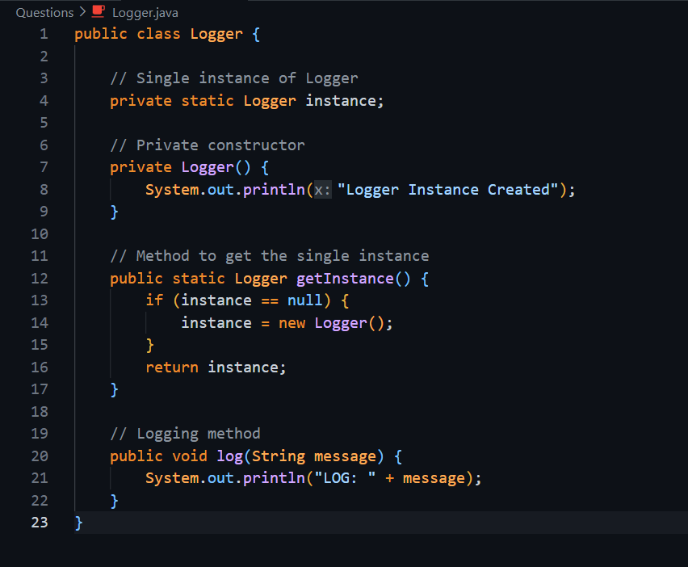
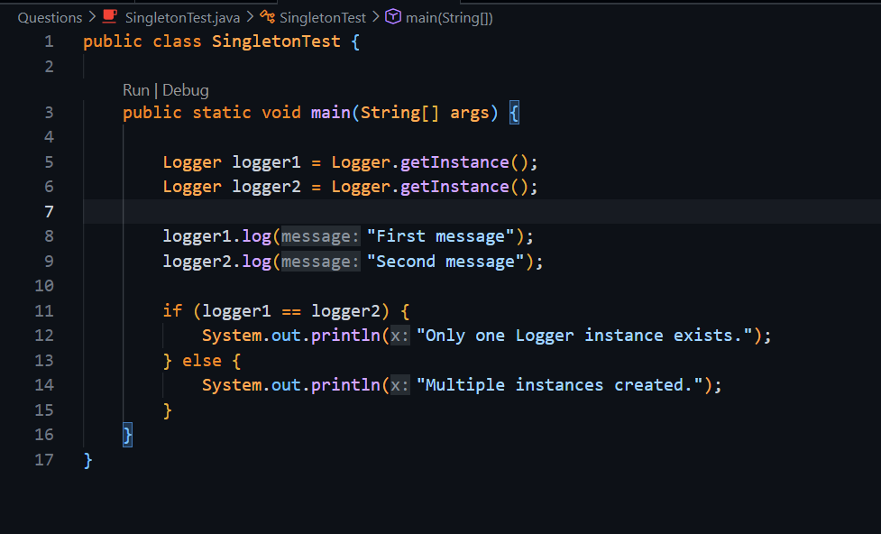
Output
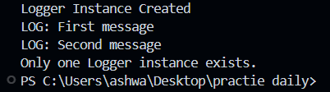

Question 2
: Implementing the Factory Method Pattern
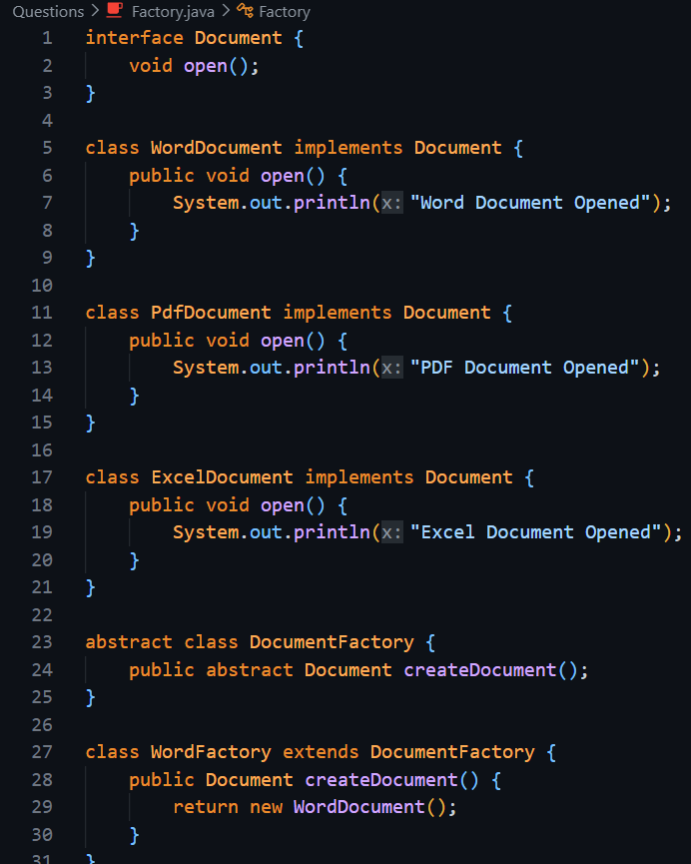
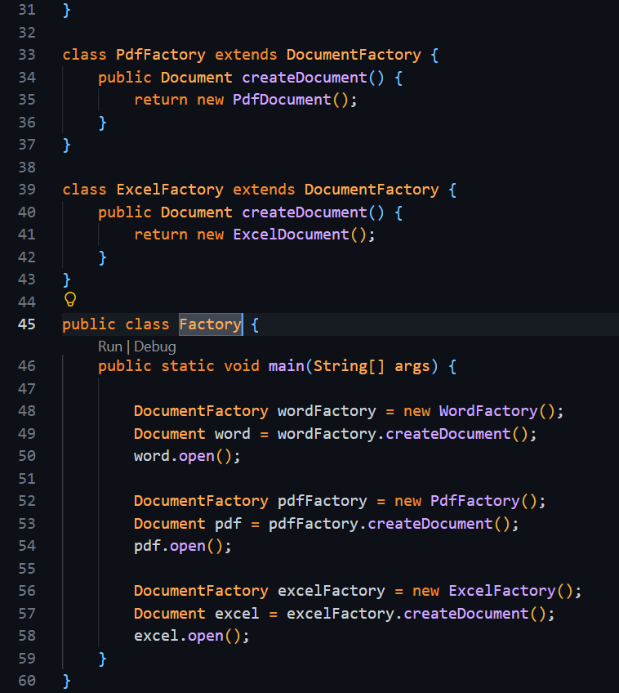
Output
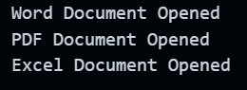

Question 3-: Implementing the Builder Pattern
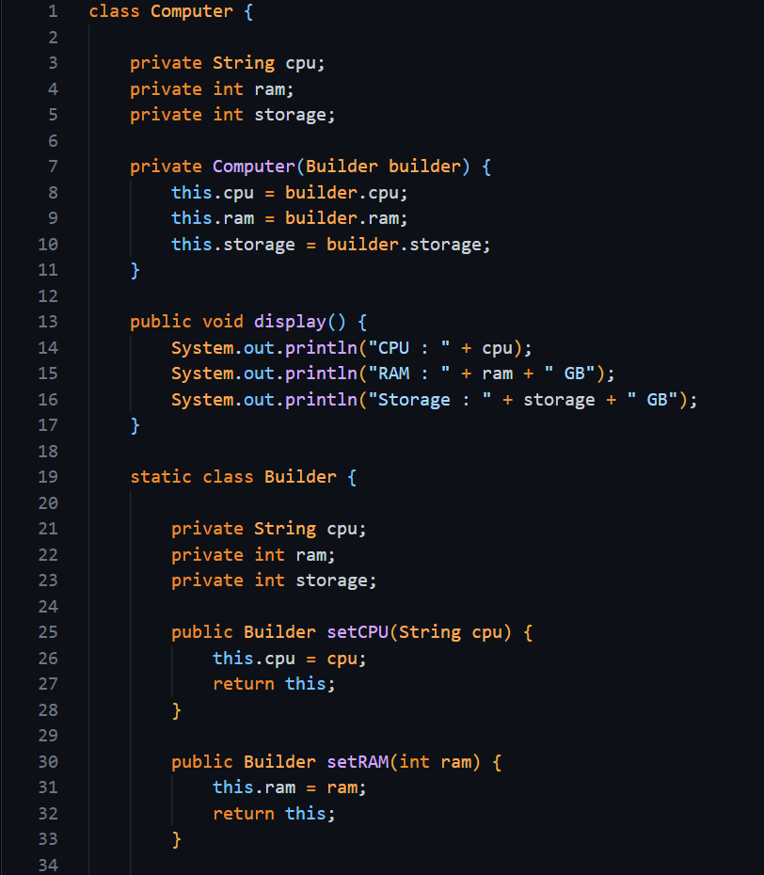
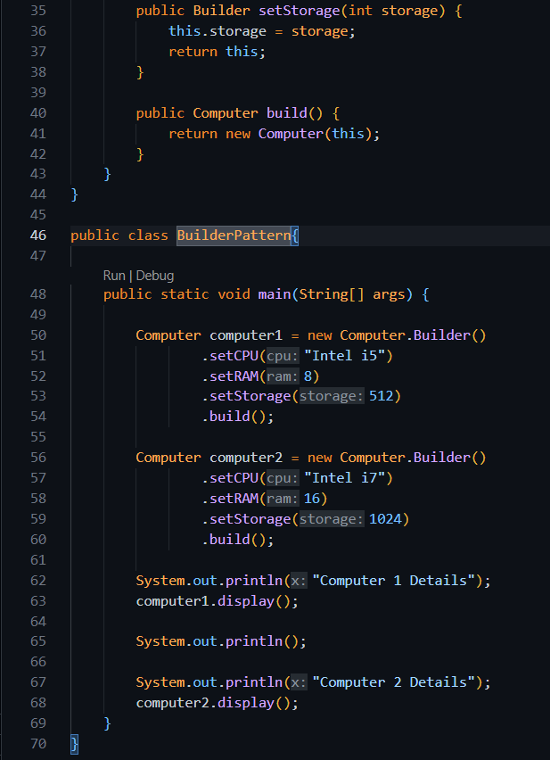
Ouput-: 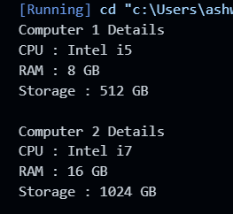
Exercise --- 4 Implementing the Adapter Pattern
Aim: Implement the Adapter Pattern for integrating different payment gateways.
Steps:
- Create project AdapterPatternExample.
- Create interface PaymentProcessor.
- Create gateway classes (Paytm, GooglePay).
- Create adapter classes implementing PaymentProcessor.
- Test payment processing using adapters.
Pattern Used: Adapter Pattern.
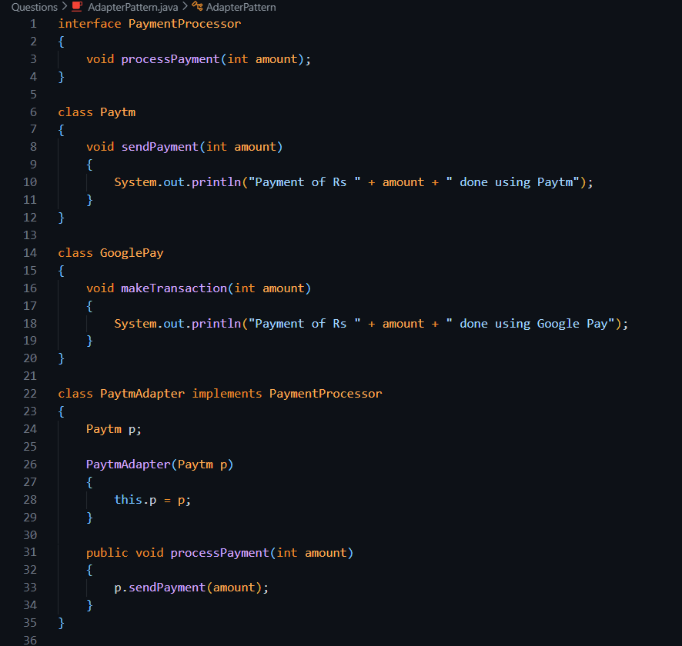

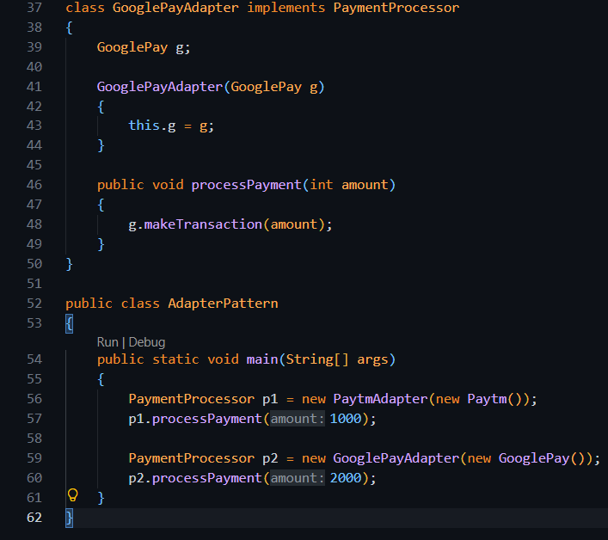
Output

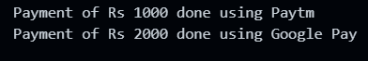

Exercise 5: Decorator Pattern
Aim: Implement the Decorator Pattern to send notifications through multiple channels like Email, SMS, and Slack.
Steps:
- Create project DecoratorPatternExample.
- Create interface Notifier with method send().
- Create class EmailNotifier implementing Notifier.
- Create abstract class NotifierDecorator.
- Create decorators SMSNotifierDecorator and SlackNotifierDecorator.
- Test sending notifications using decorators.
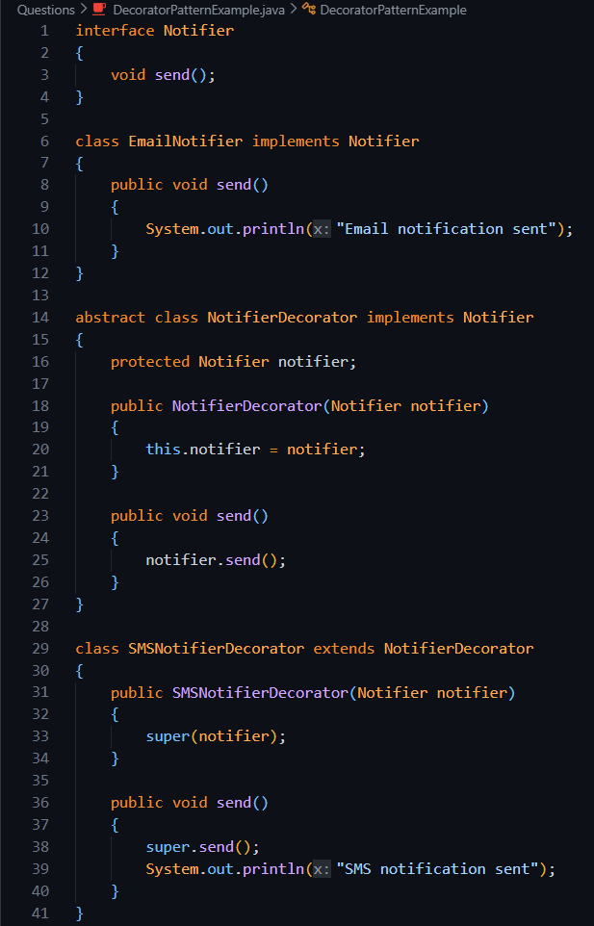
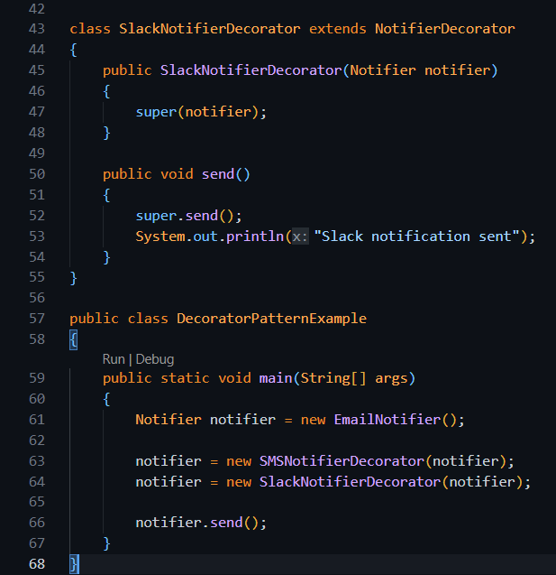
Output- 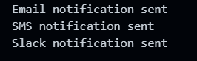
Exercise 6: Proxy Pattern
Aim: Implement the Proxy Pattern to load images using lazy initialization and caching.
Steps:
- Create project ProxyPatternExample.
- Create interface Image with method display().
- Create class RealImage implementing Image.
- Create class ProxyImage implementing Image.
- Use lazy loading and caching in ProxyImage.
- Test image loading and display.
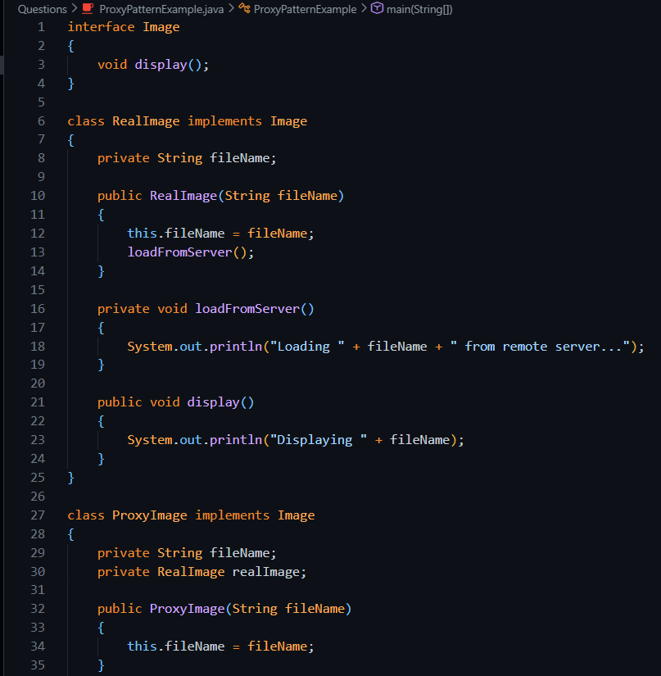
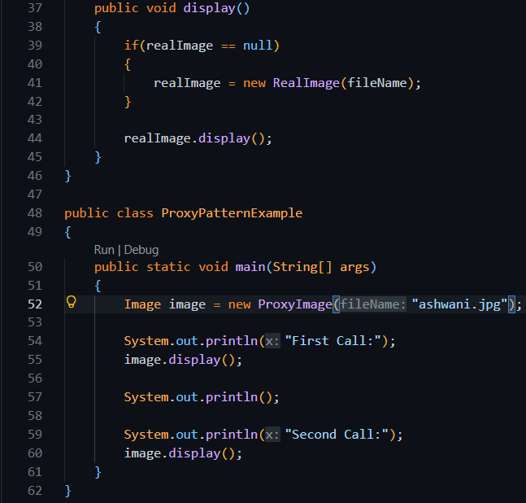
Output-----> 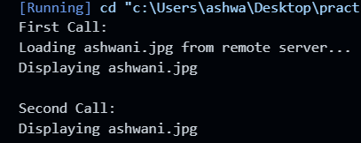
Exercise 7: Observer Pattern (Short Question)
Aim: Implement the Observer Pattern to notify multiple clients when stock prices change.
Steps:
- Create project ObserverPatternExample.
- Create interface Stock with register, deregister, and notify methods.
- Create class StockMarket implementing Stock.
- Create interface Observer with update() method.
- Create classes MobileApp and WebApp implementing Observer.
- Test observer registration and notification.
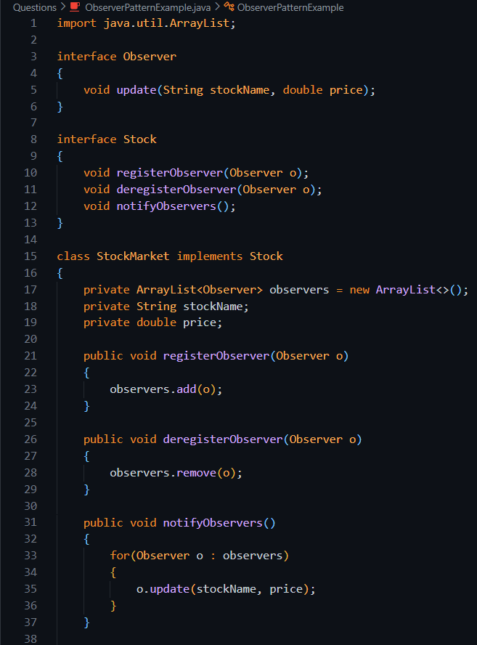
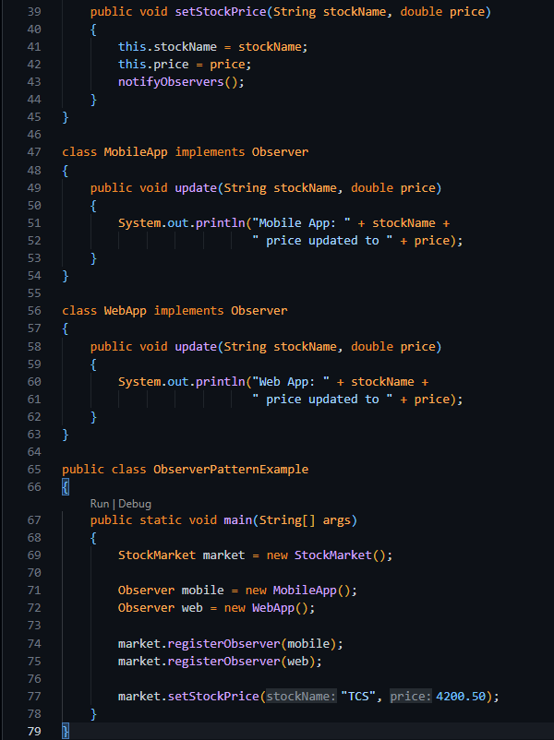
Output----->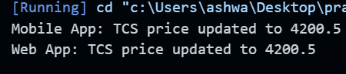

Exercise 8: Strategy Pattern (Short Question)
Aim: Implement the Strategy Pattern to select different payment methods at runtime.
Steps:
- Create project StrategyPatternExample.
- Create interface PaymentStrategy with method pay().
- Create classes CreditCardPayment and PayPalPayment implementing PaymentStrategy.
- Create class PaymentContext to execute the selected strategy.
- Test different payment methods.
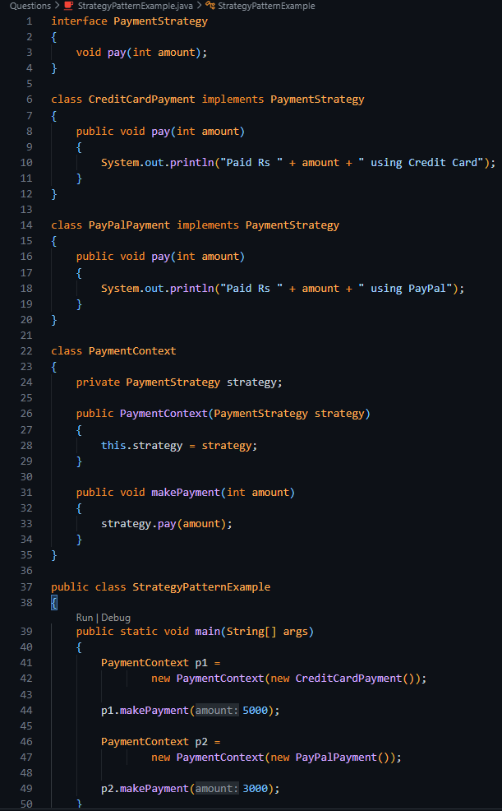
Output-----> 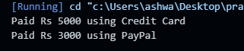
Exercise 9: Command Pattern (Short Question)
Aim: Implement the Command Pattern to control home devices like turning a light ON and OFF.
Steps:
- Create project CommandPatternExample.
- Create interface Command with method execute().
- Create classes LightOnCommand and LightOffCommand.
- Create class RemoteControl (Invoker).
- Create class Light (Receiver).
- Test command execution using RemoteControl.
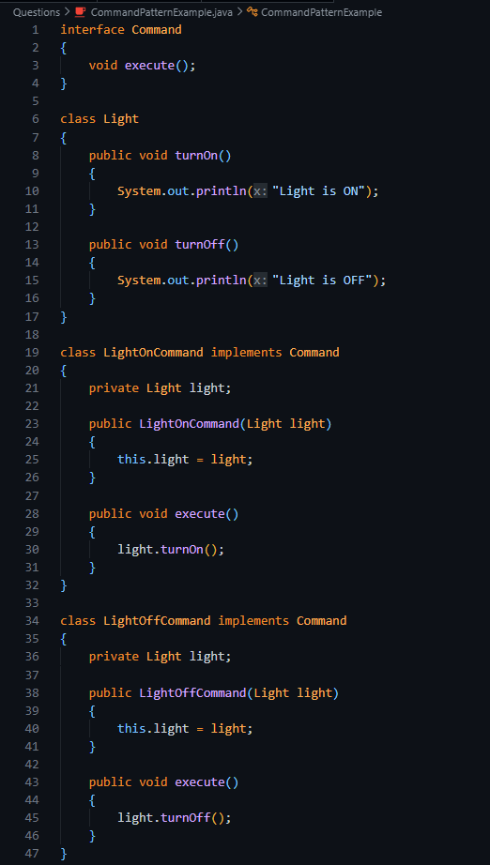
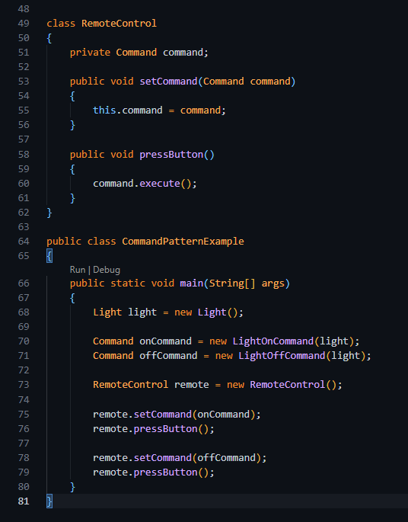
Output----> 